**Basic Circular Convolution**

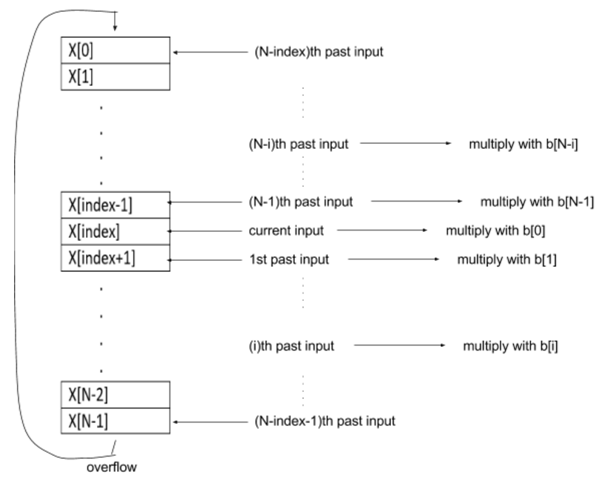

**Symmetric Circular Convolution**

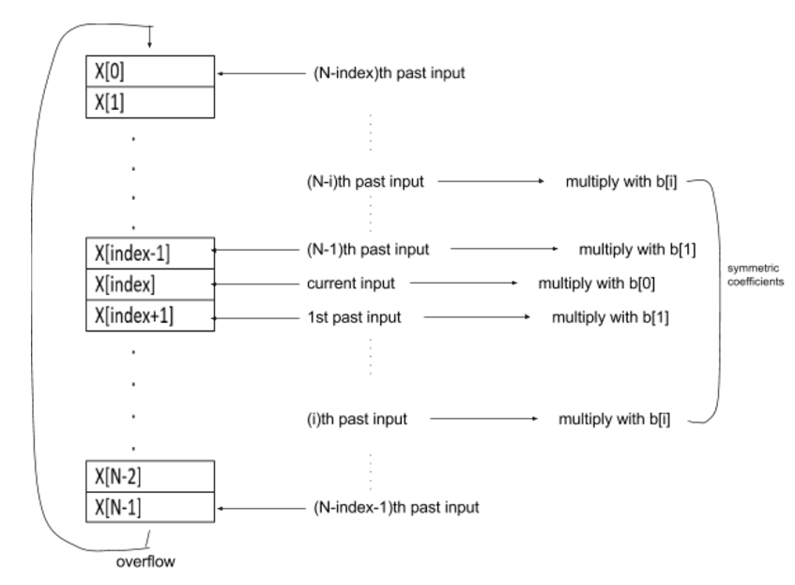

**Symmetric and Doublesize Memory Circular Convolution**

